izebuy Markets — Writer’s Brief
This is a commission. We are paying you to write a market write-up for izebuy to our specification, and this document is that specification. Follow it exactly. We are mapping the markets of Malawi: a market is not a tidy place a map app can capture, but it has its own order — the fish stalls are always on one side; the sellers change daily, the layout does not. Your job is to go to the market we assign you, walk it, and record what is where so that a stranger could read your write-up and find their way around.
Write about 2,000 words, built from what you actually see and do at the market — not padding. If you follow every instruction below you will reach that length.

How to write it
- Write in Microsoft Word, a plain document. Do not paste from any website. Type it yourself.
- Use Word’s Heading styles for the section titles below: Heading 1 for the title, Heading 2 for each main section, Heading 3 for the areas inside the walk. (Home tab → the Styles gallery → ‘Heading 2’, and so on.) Do not just enlarge or bold text — use the actual Heading style, or the page will not build.
- Use the exact section headings listed below, in this order. You may add Heading 3 areas inside the walk, but keep the Heading 2 sections as written.
- Write in the first person, as if walking the reader through the market yourself.
- Write only what is true and what you can see on the day. Do not invent history, facts, figures or walking times. If something is uncertain, leave it out; if someone told you, say who (‘traders say…’).

What every article must include
These are requirements, not suggestions. An article missing any of them will be sent back:
- The market’s full name and its town, written naturally throughout.
- Clear directions to the market from the nearest big town (never the capital).
- A full map description (Part 2 of ‘Walking the market’) so we can draw the map.
- A walk through the market that navigates by landmarks and gives real, recorded walking times (see ‘Walking the market’ below).
- Every fixed shop and service, with its opening days and hours.
- Correct, consistent spelling of all place and shop names.

Photos
- Landscape orientation (phone held sideways), good light, in focus.
- One clear subject per photo — the thing you are describing.
- Name each photo file after what it shows, lower case with hyphens: a shop → ‘lsm-general-dealers.jpg’; an area → ‘the-clothes-rows.jpg’; the cover → the market name, ‘mbayani-market.jpg’; your photo → ‘about-the-author.jpg’.
- Take one cover photo as you walk into the market and name it after the market — this is the first thing the reader sees.
- Get a nod of consent before photographing a person’s face or stall up close. If they would rather not, photograph the goods, not the person.
- Provide 8–15 usable photos across the article.

The sections to write

Heading 1 — the market’s name
Just the name, e.g. ‘Mbayani Market’.

Opening (no heading) — 2 to 3 lines · about 120–180 words
Open straight away with what this market is and where it is — the one or two sentences a stranger would need.

Heading 2 — Getting to [Market] from [nearest big town] · about 200–280 words
Write directions from the nearest big town the reader is likely to know. Never use the capital — our markets are local and the capital is too far to be useful. Include:
- Which bus or minibus stop to start from, which route, and where to get off.
- How long the trip takes and the return fare.
- The same for a taxi (time and fare).
- By car: is there parking, is it safe, and where do people actually park?
- A landmark so the reader knows they have arrived.

Heading 2 — The feel of the place · about 200–300 words
Put the reader at the market, using only what you sense on the day:
- The weather and the ground underfoot — hot and dusty, cool, muddy in the rains.
- The atmosphere — loud, calm, packed in the evening, sleepy in the morning.
- The sounds and smells as you walk in.

Heading 2 — What’s around the market · about 150–250 words
Write only what is physically there, today, that you can see and photograph — true things that cannot be disputed and that are specific to THIS market:
- Is it on a main road, or down a side road?
- Is there a river, stream, forest, hill or field beside it?
- Are there schools, a church, a clinic or another landmark nearby?
If a trader or local genuinely tells you a piece of the market’s history you may add one line, attributed (‘traders say…’). Do not invent it; if no one tells you any, leave it out.

Heading 2 — What [Market] is famous for · about 200–300 words
- The one thing people go there specifically to buy.
- Why a shopper would choose this market over another for it (price, choice, freshness).
- What else can be bought there, even if the market is not famous for it.
- How bargaining works there, if it is a bargaining market.

Heading 2 — Walking the market: where everything is (the most important section)
This is the heart of the article and the whole reason for the job: it maps the market so a stranger could find their way around. You will produce two things from one visit — a MAP DESCRIPTION (we turn your words into a map; you do not draw it) and a GUIDED WALK (the part the reader reads). Do the fieldwork first, then write. Work through the three parts below in order, step by step.

Part 1 — Map the market on the ground (do this first, before you write)
Take your phone, a pen and some paper, and walk the market doing these steps in order. This is the fieldwork everything else is built from:
- As you walk in from the main entrance, take the cover photo — this is the reader’s first sight of the market. Name it after the market (e.g. ‘mbayani-market.jpg’).
- Walk the whole outer edge of the market once. Notice its shape and what borders it on each side — the main road, a stream, a fence, a field, a hill.
- Find every way in and out (the gates and entrances).
- Walk the lanes and give each area a name by what is sold there — clothes, fruit and vegetables, fish, food, hardware, and so on. These are your zones.
- For each area, pick ONE permanent landmark nearby, and check it passes three tests: it never moves, you can see it from a distance, and there is nothing else like it. Use lasting things — a big tree, the stream, a painted or named shop, the mill, a church. NEVER use a trader or their goods; those change every day.
- Work out the path a newcomer walks from each area to the next, and note what the path does — does it bend, fork, or go up or downhill?
- Measure distance with your own steps: pace out a known length once so you know your stride, then pace the lanes, and time each walk on your phone’s stopwatch. Write the real numbers — never guess a walking time.
- Take one photo of each zone (named after it), one of each landmark, and a few of the shops and stalls. Name every photo after what it shows.

Part 2 — Write the map description (you describe it; we draw it)
You are NOT drawing the map — leave that to us. Your job is to describe the market in words so exact that someone who has never been there could draw it correctly from your description alone. We use an artificial-intelligence drawing tool to make the map, and it knows only what you tell it — so you must spell out every piece it needs. Picture describing a room to someone on the phone who has to sketch it without seeing it.
Write it as a numbered list under the heading ‘Map description (for drawing)’, and follow these rules:
- Describe everything from ONE position: standing at the main entrance, looking in. Do not move your viewpoint around.
- Use the edges as your compass — ‘toward the road’, ‘toward the stream’, ‘toward the mill side’, ‘the near side / the far side’. These never change, so they cannot be misread. Avoid plain ‘left’ and ‘right’.
- Anything you do not mention, the tool will straighten or guess. So if a path bends, forks, or an area is an odd shape, say so clearly.
- Pin every landmark to an exact spot (‘on the corner where the path turns downhill’, ‘at the far end of the clothes’).
- Give the walking time for each leg.
Cover these six things, in this order: (1) the market’s shape and what is on each edge; (2) the entrances; (3) each zone and where it sits; (4) the landmarks and where they sit; (5) the paths between the zones, and whether they bend; (6) the walking times.
Example — a good map description (this is the standard we want):
- Shape and edges: the market is a rough rectangle on a slope. The M1 main road runs along the top edge; as you enter from the road the ground slopes downhill away from you. A stream runs along the bottom edge, the farthest side from the road.
- Entrances: one main entrance, in the middle of the top edge, straight off the M1.
- Zones (standing at the entrance, looking in): the clothes are straight ahead, just inside — the first and biggest zone. The food stalls are right beside the entrance, toward the mill side. The fruit and vegetables are further in and downhill from the clothes, filling the middle of the slope. The fish is at the very bottom, in the corner nearest the stream.
- Landmarks: a green-painted shop sits on the corner where the path leaves the clothes and bends downhill toward the produce. The maize mill is over toward the food-stall side. The fixed shops (LSM, Mutheya, First Quality) line the top edge near the entrance.
- Paths: from the entrance you walk straight into the clothes. At the green shop the path bends and goes downhill into the produce — this is a bend, not a straight line. From the produce you carry straight on down to the fish at the bottom.
- Times: entrance to clothes, a few seconds. Clothes to produce, about two minutes. Produce to fish, under a minute. End to end, about five minutes.
From a description like that — and nothing else — here is the map we produce for you. You never have to draw anything:
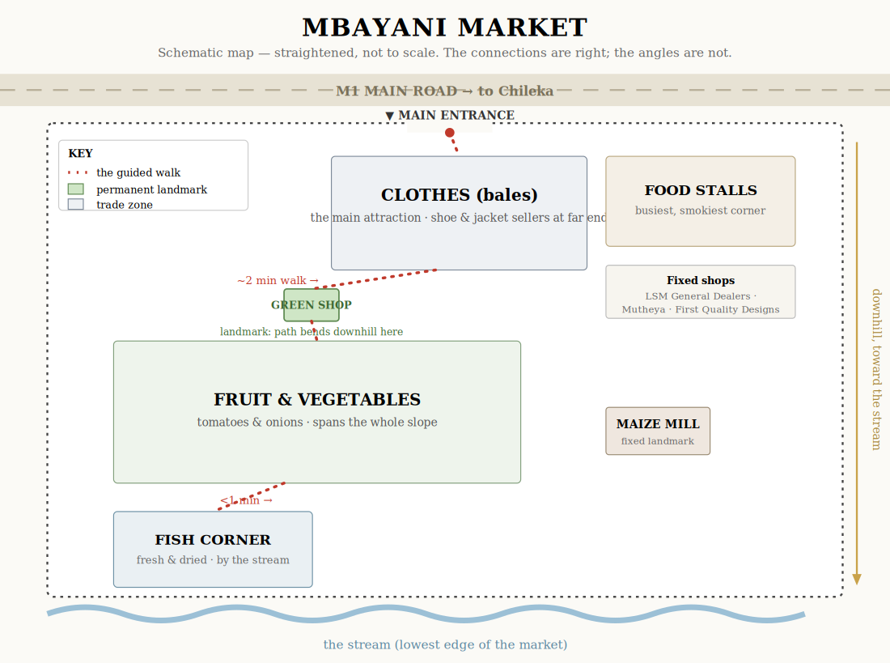
The map drawn from the example description above. Notice it straightens the lanes but keeps every connection, landmark and time the writer gave — that is all it needs.

Part 3 — Write the guided walk
Now write the walk for the reader. Take them with you from the entrance through each area in turn, using everything you gathered in Part 1. Rules:
- Start at the entrance, with the cover photo, and describe the first area you reach — usually the market’s main attraction.
- Move the reader from one area to the next by LANDMARKS THEY CAN SEE — ‘walk back to the entrance and past the green-painted shop’, ‘follow the slope down towards the stream’. Never use ‘left’, ‘right’ or compass directions; anchor every direction to a fixed thing — a painted shop, the mill, the stream, the gate.
- Give the real, timed distance for each leg — ‘about a two-minute walk; I timed it’. Do not guess or round up.
- For each area give: what is sold there, how far it spreads, and a golden nugget — one specific, useful local tip (‘come early for first pick of the bales’; ‘the dried-fish sellers drop their price in the evening rather than carry stock home’).
- Use a Heading 3 for each area you walk into.

Heading 2 — Shops, services and opening hours · about 150–300 words
The fixed shops and services (not the daily stalls). For each one give:
- Its name.
- What it sells or does, in a line.
- Opening days and hours.
- A photo named after the shop.
Include services too — mills, barbershops, salons, airtime, and so on.

Heading 2 — Practical tips · about 150–250 words
- Best time to go overall, and specifically for fresh food.
- When it is too crowded to bother.
- Your favourite stall or shop, and why.
- Anything a first-time visitor should know before going.

Heading 2 — Our honest take · about 200–300 words
No star ratings. Describe what the market is actually like so the reader can judge:
- Value — is it cheap, and is the quality decent for the price?
- Cleanliness — describe plainly what you saw (litter, drainage, mud).
- Safety — describe your OWN experience (‘I kept my bag in front in the busy aisles’, ‘I parked outside and the car was fine’). General crowd advice is fine. Never accuse a named shop or person of theft or wrongdoing.
- Would you go back, and who is this market right for?

Heading 2 — About the Author (always the last section) · about 60–100 words
A short bio you write yourself, in the third person: your name, where you are based, what you do, a line of personality, and a contact email. Include your photo, named ‘about-the-author.jpg’.

Before you submit — checklist
- Title in Heading 1; every section in the Heading 2 style (Heading 3 for the walk’s areas).
- Sections in the order above, with About the Author last.
- About 2,000 words, and ‘Walking the market’ is the longest section.
- A complete ‘Map description (for drawing)’ written, and real recorded walking times in the walk.
- Directions navigate by visible landmarks — no left/right or compass.
- 8–15 landscape photos, each named after what it shows; one cover photo named after the market; one author photo.
- No invented facts, history or times; anything uncertain is attributed.
- No named shop or person accused of anything.
- Plain Word — no pasted web content, no tables, text boxes, coloured text or fancy fonts (they are removed).

